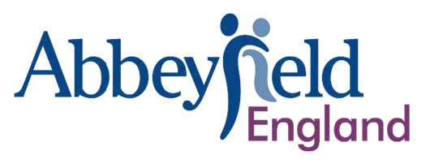

Chair of the Board – Abbeyfield England
Help thousands of older people live with dignity, community, and purpose.
Click here to download our full recruitment pack

Voluntary role (expenses paid) • Hybrid (national & online)
Do you believe every older person deserves to live in a connected, caring community? Abbeyfield England is seeking a new Chair to lead our Board through the next chapter of our work, supporting a unique national network of local Abbeyfield member societies.
Abbeyfield England is a national membership body. We are a registered charity. Our member societies operate not for profit houses and homes across England, providing safe, supported, and sociable housing and care for older people – ranging from small volunteer-led houses to large extra-care services. Abbeyfield’s work has enjoyed longstanding Royal Patronage, currently held by His Majesty King Charles III. The movement’s roots go back to 1956.

The Role
Abbeyfield England was established in 2022 as the new umbrella body for the movement. Now that we have the main building blocks in place, we’re seeking a new Chair to lead a collaborative, strategic and purposeful Board through the next period of development, including our 70th Anniversary year in 2026.

You’ll:
- Provide strategic leadership and ensure strong, values-led governance
- Support and appraise the General Secretary and ensure an effective Board culture
- Build trust and engagement across our federated membership
- Represent Abbeyfield England with pride, both within our movement and externally

The Chair will also play a key ambassadorial role as the Abbeyfield movement marks 70 years of Abbeyfield’s impact, including speaking opportunities, profile-raising, and engaging with member societies across the country.

Time Commitment
The anticipated time commitment is 15–20 days per year, including:
- 4 formal Board meetings (held in-person across our member societies)
- Biennial Membership Conference
- Quarterly Finance Committee & Operations Committee meetings (Chair may attend)
- Twice-yearly HR Committee meetings
- Occasional representation at national or movement-wide events
We will ensure a supportive induction and an optional co-chairing handover with the current Interim Chair from December 2025 to March 2026.

About You
We’re not looking for status. We’re looking for someone who believes in what Abbeyfield stands for and who can bring warmth, good judgement, and strategic thinking to this leadership role.
Ideally you would have experience within a membership organisation, and perhaps already have chaired a Board. In addition, we are seeking
- Leadership and governance experience in a charity, housing, care, or complex service organisation
- Strong listening, communication, and relationship-building skills
- Financial literacy and comfort with strategic risk
- A passion for helping older people live connected and fulfilling lives
We welcome candidates from all backgrounds and will make reasonable adjustments throughout the process.

How to Apply
Please send:
- Your CV (required)
- You are also welcome to include a link to your LinkedIn profile
- A short covering letter (or video) explaining why you’d like to Chair Abbeyfield England and what you would bring to the role

Send to: AE.Board@abbeyfieldengland.com
Deadline: Monday 21 October 2025
Interviews: Week commencing 3 or 10 November 2025
Board appointment: 2 December 2025
Co-chairing handover: December 2025 – March 2026
Chair formally in post: April 2026
If you’d like more information or an informal conversation with the Chair before applying, email AE.Board@abbeyfieldengland.com

Abbeyfield is a movement of people who believe in ageing well - in homes filled with warmth, community, and care. Join us to help make that vision a reality.

Registered Charity No. 1213760

